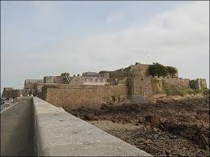
Castle Cornet Trip Monday 9th October 9:15-11:45am
We’re off to Castle Cornet to learn about life in Tudor times in Guernsey.
Children need to come to school as normal in their school uniform although please make sure they are wearing a sensible pair of shoes-trainers may be worn. Please ensure you are prepared for all weathers. But if it is windy, cold or wet children must have a warm, waterproof coat-it gets very cold at the castle and part of the trip is outside. We will return by lunchtime, packed lunches as normal.

Castle Cornet Trip Monday 9th October 9:15-11:45am
We’re off to Castle Cornet to learn about life in Tudor times in Guernsey.
Children need to come to school as normal in their school uniform although please make sure they are wearing a sensible pair of shoes-trainers may be worn. Please ensure you are prepared for all weathers. But if it is windy, cold or wet children must have a warm, waterproof coat-it gets very cold at the castle and part of the trip is outside. We will return by lunchtime, packed lunches as normal.

