Numeracy Homework – Due in on the 24.05.16
Your task is to find objects at home that you can find the ratio and proportion of. It can be anything from toys to food! Write down at least 5 different examples. Ratio describes 'for/to every' and Proportion describes 'in every'.
For example:
Lego – What is the ratio of yellow to every red? What is the proportion of red pieces? Yellow pieces?
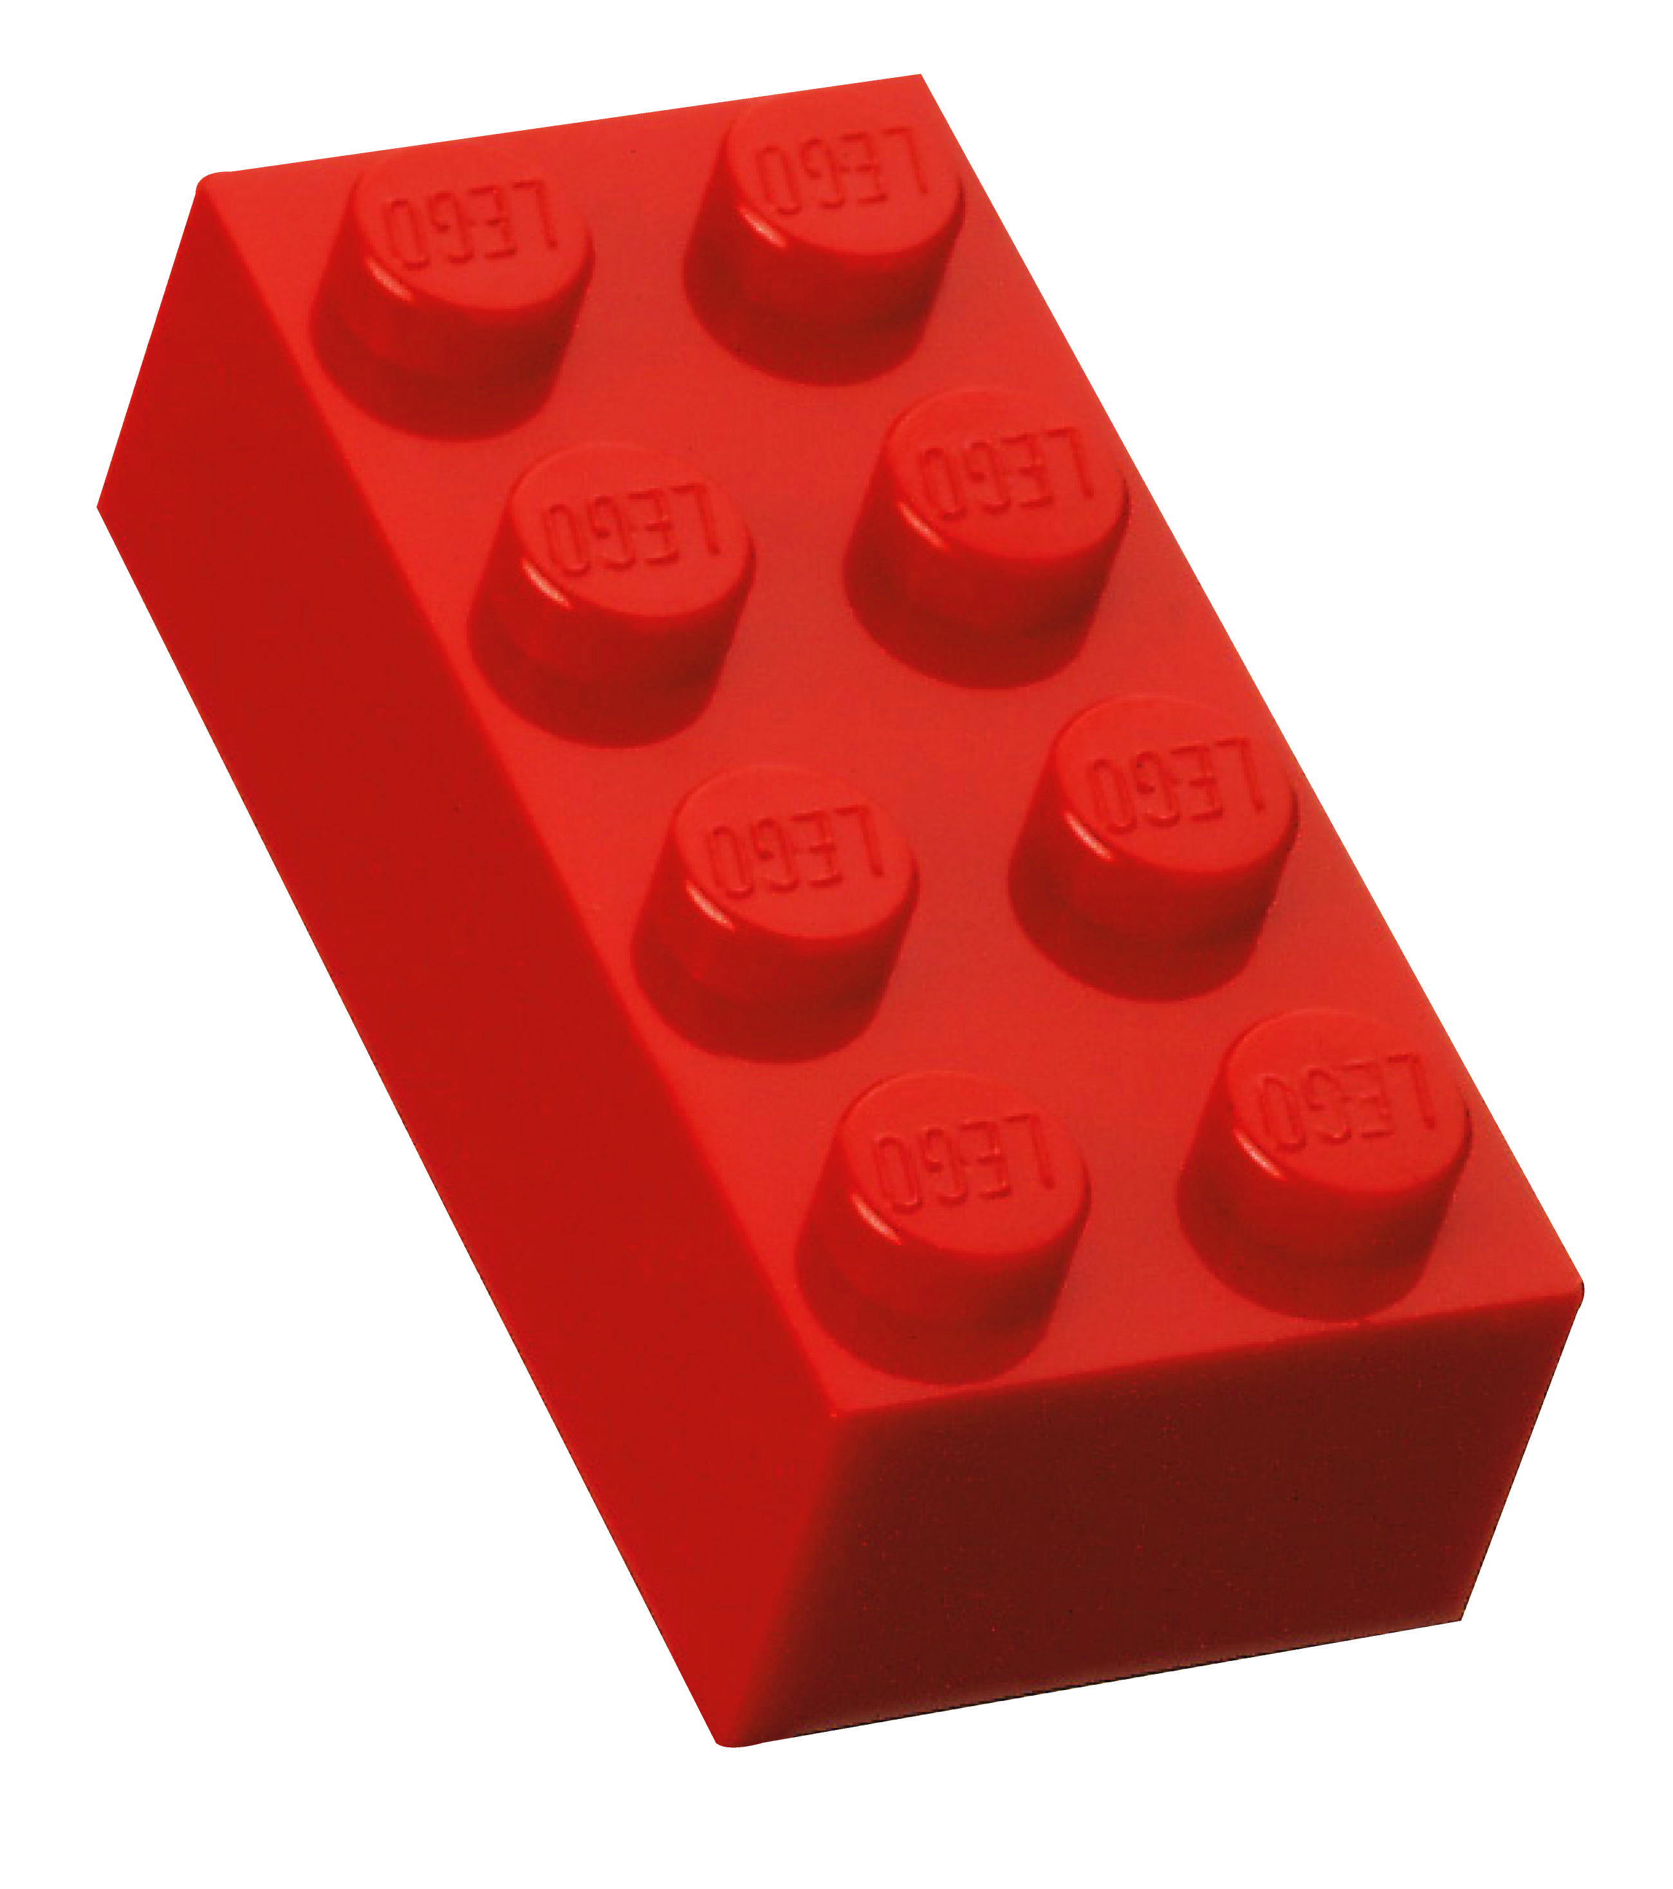

Ratio = 4 red pieces to every 8 yellow pieces (4:8)
Proportion of red pieces = 4 red pieces in every 12 pieces of Lego (4/12)
Proportion of yellow pieces = 8 yellow pieces in every 12 pieces of Lego (8/12)
Challenge: If possible, simplify the ratio, e.g. 4:8 = 1:2 or the fractions, e.g. 8/12 = 4/6 = 2/3

Numeracy Homework – Due in on the 24.05.16
Your task is to find objects at home that you can find the ratio and proportion of. It can be anything from toys to food! Write down at least 5 different examples. Ratio describes 'for/to every' and Proportion describes 'in every'.
For example:
Lego – What is the ratio of yellow to every red? What is the proportion of red pieces? Yellow pieces?

Ratio = 4 red pieces to every 8 yellow pieces (4:8)
Proportion of red pieces = 4 red pieces in every 12 pieces of Lego (4/12)
Proportion of yellow pieces = 8 yellow pieces in every 12 pieces of Lego (8/12)
Challenge: If possible, simplify the ratio, e.g. 4:8 = 1:2 or the fractions, e.g. 8/12 = 4/6 = 2/3

