Challenge: Averages around the home
We Are Learning To find an average (the mean)
- Add all the numbers.
- Divide the answer by how many numbers there are.
- Use a method for addition (partitioning / column) and division (number line, compact, bus stop).

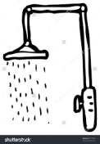
Here are some ‘average’ facts from Mrs Judd’s home:
- Average time she spends in the shower (Monday 15 minutes, Tuesday 10 minutes, Wednesday 5 minutes, Thursday 12 minutes, Friday 18 minutes) = 60 ÷ 5 = 12 minutes

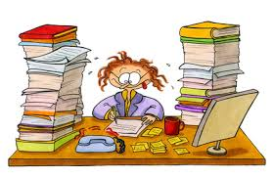
- Average number of books she marks every day (Monday 27, Tuesday 20, Wednesday 54, Thursday 18, Friday 1) = 120 ÷ 5 = 24 books a day

- Average times she opens the fridge every hour in the evening (5:00-6:00pm; 15 times, 6:00-7:00pm: 8 times, 7:00-8:00pm, 6 times 8:00-9:00pm: 3 times, 9:00-10:00pm: 1) = 33 ÷ 5 = 6 r 3 = 6 3/5 = 6.6
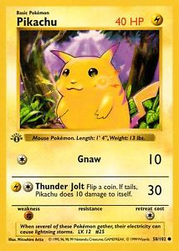
So rounded up = 7 times an hour
- The average number of hit points on her Pokémon cards: 130 + 40 + 100 + 50 + 60 = 380 ÷ 5 = 76 points

Find some ‘averages’ around your house!

