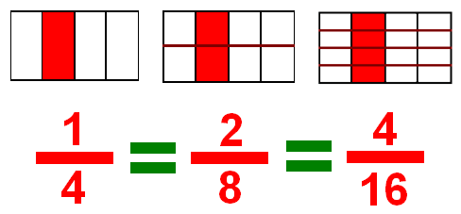

WALT: Find equivalent fractions
Success criteria:
- Use a fraction wall
- Use a ruler to find fractions that are the same length on the wall
- What you do to the numerator you do to the denominator
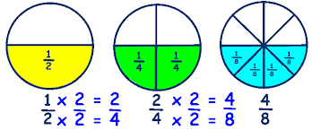
Choose one or more of the challenges below:-
- Use your fraction wall to find equivalent fractions of:-
1/2
1/3
1/4
Optional
1/5
- Use your fraction wall to find as many equivalent fractions as you can. Explore fractions that have a numerator>1 e.g. 2/5 = 4/10, 8/20 etc.

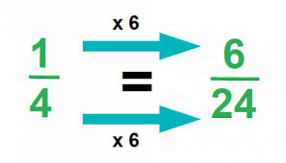
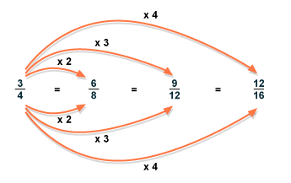
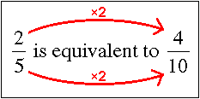
- Explore equivalent fractions without using a fraction wall – explore at least 5 different fractions e.g.

