Mrs C Mason St Martin’s Primary School
Headteacher Route des Coutures
St Martin’s
GUERNSEY
Telephone (01481) 756060 GY4 6HN
Facsimile (01481) 238706
Email office@stmartins.sch.gg

5th January 2017

Year 4 Spring Newsletter

Dear Parents,
Happy New Year! The children worked very hard last term and we were extremely proud of all their commitment and enthusiasm. We have another exciting term ahead with lots to look forward to.

This term we will be mainly focusing on science. We start the year with a range of science investigations which will be planned and carried out by the children. The topics to be studied are: Electricity, Keeping Warm and Forces and Friction. There will be an exciting ‘Feel the Force’ day to look forward to where ‘extra Stormtroopers’ will be needed! We will let you know nearer the time.

Numeracy/Literacy
Please see the information posted on our blog every Friday for specific areas of study. If you wish to subscribe to the blog please let us know. We are very keen to continue the strong link with parents/carers through the blog, email, by phone or dropping in to see us. We really do welcome regular communication from home. New targets for this term will be sent home shortly.

Literacy and Numeracy homework will continue to be set on alternate Fridays and collected on the following Wednesday. We will hold a homework club on Monday lunchtimes for those who need some extra support from teachers. There will also be the opportunity to use laptops should internet access be required as from time to time we may post a useful website on the blog for the children to use.

Children will receive their termly spelling grid soon. Children should practice their spellings regularly and will be tested every 3 weeks.

This term we are really celebrating the love of reading. We are passionate about children becoming self-motivated readers in the hope that they can’t put a book down! We would love to see what the children are reading at home so please record reading in the blue record book, where effort will be celebrated. We encourage the children to read aloud to an adult at least three times a week as it helps develop vocabulary, improve comprehension and expression and reinforces the use of punctuation. Please look on the blog for a useful link for advice in supporting your child with reading: https://stmartinsyear4blog.edublogs.org/category/literacy/

PE
Same as last term:-
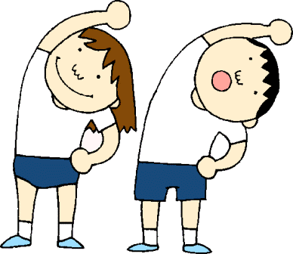
Outdoor Games is on a Wednesday for all 3 classes and Tuesdays for Mrs Dowding’s and Miss Dyke’s class and Friday for Mrs Karia’s class. Please ensure children bring sensible, warm PE clothing, including a change of footwear.

Indoor PE is on Monday for Miss Dyke’s Class, Tuesday for Mrs Karia’s class (Yoga) and Thursday for Mrs Dowding’s class.

Theatricals!
Year 4 children will be performing the Easter Service at the end of term. Open auditions will be held just before half-term and we will be encouraging anyone who would like to sing or act, on their own or as part of a small group, to come along. However, all the children will be taking part and hopefully will gain a great sense of achievement from the whole experience. More details to follow later on in the term.
Thank you to all the parents and carers who have helped out over the last term -you made such a difference and we appreciate any support. If you would like to help out on a regular basis with numeracy, reading, etc then please inform your child’s class teacher. We are particularly looking for helpers at the end of the day for 10 minutes to hear readers or help with small maths tasks. So, if you arrive early at 2:30pm to sit in the car park feel free to join us instead!

Please do not hesitate to contact us if you require further information.

We hope that you find this letter helpful and we wish to thank you for your continued support.

Best wishes for the New Year and we are looking forward to another fantastic term!

Year 4 Team

