Tudor Crime and Punishment
During the Tudor period, there were no police. However, laws were harsh and wrongdoing was severely punished. Many punishments were very, very cruel. People believed if a criminal’s punishment was severe and painful enough, the act would not be repeated and others would deter from crime as well.
A wooden pillory.
What was the Pillory?
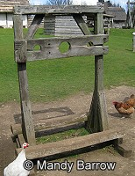
For those who committed a minor crime, the Pillory was one method of punishment used.
The Pillory was a T shaped block of wood with holes for the hands in the crossbar of the T. Criminal’s heads and/or various limbs were inserted; then the boards were locked together to secure the captive. In being forced to bend forward and stick their head and hands out in front of them, offenders in the Pillory would have been extremely uncomfortable during their punishment.
Where were people punished?
When a person was being punished, they would have to stand in the device, in the middle of the market, to be ridiculed by passers-by. This would often take place during the middle of the day. Criminals were frequently placed on platforms to increase public visibility of the offender. Usually, a placard detailing the crime was placed nearby; these punishments generally lasted only a few hours.
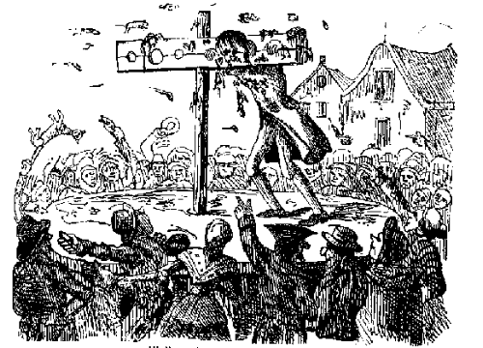
Enjoying the Entertainment!
Those who gathered to watch the punishment typically wanted to make the offender's experience as unpleasant as possible. In addition to being jeered and mocked, those in the pillory might be pelted with rotten food, mud, offal, dead animals, and animal excrement. As a result, criminals were often very dirty by the end of their punishment, their faces and hair grimy and covered with what they had been pelted with. Sometimes people were killed or maimed in the pillory because crowds could get too violent and pelt the offender with stones, bricks and other dangerous objects.
Above you can a see a criminal within the Pillory having rotten food thrown at them by the public.
Did you know?
You could be put in the pillory for not wearing a hat on Sunday or stealing a loaf of bread!
As you can see, the punishment for minor crimes in the Tudor
Period was extreme.

In year 4, we have been learning about Tudor Crime and Punishments. Using the text map and actions, practise re-telling the information text based on the pillory (the text is on the back to help you).

