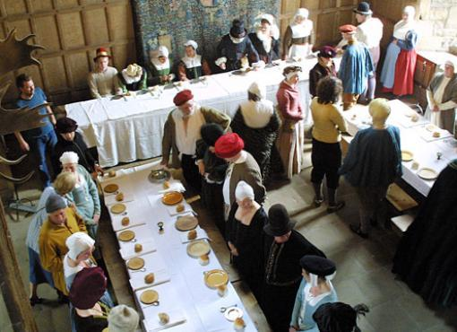
Great British Bake Off has a Tudor theme this week! Watch it on Wednesday 12th October
History homework
due Friday 4th November

Your homework is to find out about Tudor food and present your information in an exciting way. You have just over 3 weeks to complete this homework although one of these weeks is the half term holiday which we want you to enjoy. If you need an extension please let us know!

Tudor Food
Can you find out about some of the foods you would have eaten as a Tudor?

Research in the usual way. Please use the links on the blog for safe sites.

Useful website are:

http://www.primaryhomeworkhelp.co.uk/tudors/food.html

www.historyonthenet.com/Tudors/food.htm

www.the-tudors.org.uk/tudor-food.htm

http://cookit.e2bn.org/historycookbook/1426-vegetable-pottage.html

You may come to homework club on Mondays if you don’t have internet access at home or need some help. We also have books at school we can lend to you as well.
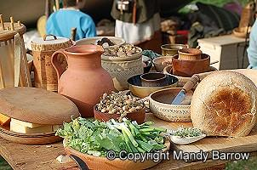
You can present your homework in any way you would like.

E.g. As a picture, poster, a model (play dough or plasticine), a menu, or even an edible offering (come dine with me Tudor style)!
We think you can come up with some even better ideas!

Please hand in on Friday 4th November

